READ AND FOLLOW ALL SAFETY INSTRUCTIONS!

SAVE THESE INSTRUCTIONS AND DELIVER TO OWNER AFTER INSTALLATION

* To reduce the risk of death, personal injury or property damage from fire, electric shock, falling parts, cuts/abrasions, and other hazards please read all warnings and instructions included with and on the fixture box and all fixture labels.
* Before installing, servicing, or performing routine maintenance upon this equipment, follow these general precautions.
* Installation and service of luminaires should be performed by a **qualified licensed electrician**.
* Maintenance of the luminaires should be performed by person(s) familiar with the luminaires’ construction and operation and any hazards involved. Regular fixture maintenance programs are recommended.
* It will occasionally be necessary to clean the outside of the refractor/lens. Frequency of cleaning will depend on ambient dirt level and minimum light output which is acceptable to user. Refractor/lens should be washed in a solution of warm water and any mild, non-abrasive household detergent, rinsed with clean water and wiped dry. Should optical assembly become dirty on the inside, wipe refractor/lens and clean in above manner, replacing damaged gaskets as necessary.
* **DO NOT INSTALL DAMAGED PRODUCT!** This luminaire has been properly packed so that no parts should have been damaged during transit. Inspect to confirm. Any part damaged or broken during or after assembly should be replaced.
* Recycle: For information on how to recycle LED electronic products, please visit [www.epa.gov](http://www.epa.gov).
* These instructions do not purport to cover all details or variations in equipment nor to provide every possible contingency to meet in connection with installation, operation, or maintenance. Should further information be desired or should particular problems arise which are not covered sufficiently for the purchaser’s or owner’s purposes, this matter should be referred to Acuity Brands Lighting, Inc.

WARNING

RISK OF BURN

WARNING

RISK OF ELECTRIC SHOCK



* Disconnect or turn off power before installation or servicing.
* Verify that supply voltage is correct by comparing it with the luminaire label information.
* Make all electrical and grounded connections in accordance with the National Electrical Code (NEC) and any applicable local code requirements.
* All wiring connections should be capped with UL approved recognized wire connectors.



* Allow lamp/fixture to cool before handling. Do not touch enclosure or light source.
* Do not exceed maximum wattage marked on luminaire label.
* Follow all manufacturer’s warnings, recommendations and restrictions for: driver type, burning position, mounting locations/methods, replacement and recycling.

CAUTION

RISK OF FIRE

CAUTION

RISK OF INJURY



* Wear gloves and safety glasses at all times when removing luminaire from carton, installing, servicing or performing maintenance.
* Avoid direct eye exposure to the light source while it is on.



* Keep combustible and other materials that can burn, away from lamp/lens.
* Do not operate in close proximity to persons, combustible materials or substibg
* Acnes affected by heat or drying.

CAUTION: RISK OF PRODUCT DAMAGE



* Never connect components under load.
* Do not mount or support these fixtures in a manner that can cut the outer jacket or damage wire insulation.
* Controls for dimming, auto-sensing, or remote control of a luminaire that are not factory-wired to the luminaire must be checked for compatibility with the luminaire prior to installation. LED fixtures must be powered directly off a switched circuit.
* Unless individual product specifications deem otherwise: Do not restrict fixture ventilation. Allow for some volume of airspace around fixture. Avoid covering LED fixtures with insulation, foam, or other material that will prevent convection or conduction cooling.
* Unless individual product specifications deem otherwise: Do not exceed fixtures maximum ambient temperature.
* Only use fixture in its intended location.
* LED products are Polarity Sensitive. Ensure proper Polarity before installation.
* Electrostatic Discharge (ESD): ESD can damage LED fixtures. Personal grounding equipment must be worn during all installation or servicing of the unit.
* Do not touch individual electrical components as this can cause ESD, shorten lamp life, or alter performance.
* Some components inside the fixture may not be serviceable. In the unlikely event your unit may require service, stop using the unit immediately and contact an ABL representative for assistance.
* Always read the fixtures complete installation instructions prior to installation for any additional fixture specific warnings.
* Always ensure that the electrical distribution system is up to NEC (and any applicable local code) requirements.
* Verify that power distribution system has proper grounding. Lack of proper earth ground can lead to fixture failure and may void warranty.

All luminaires that contain electronic devices that generate frequencies above 9kHz from any component within the luminaire comply with Part 15 of the FCC Rules. Operation is subject to the following two conditions:

(1) This device may not cause harmful interference

(2) This device must accept any interference received, including interference that may cause undesired operation

**Failure to follow any of these instructions could void product warranties. For a complete listing of product Terms and Conditions, please visit www.acuitybrands.com.**

**Our Brands** **Indoor/Outdoor Indoor Lighting Outdoor Lighting Controls Daylighting**   
 [Lithonia Lighting](http://www.lithonia.com/) Gotham American Electric Lighting Dark To Light SunOptics   
 [Carandini](http://www.carandini.com/en/index/index.php) Mark Architectural Lighting Antique Street Lamps LC&D  
 [Holophane](http://www.holophane.com/) Peerless Hydrel ROAM   
 [Reloc](http://www.relocwiring.com/) Renaissance Lighting Tersen Sensor Switch

Light Concepts Winona Lighting Synergy

**Acuity Brands Lighting, Inc. assumes no responsibility for claims arising out of improper or careless installation or handling of its products.**

ABL LED General Warnings, Form No. 503.203

© 2010, 2016 Acuity Brands Lighting, Inc. All rights reserved. 12/01/10

VERJURE PRO SERIES “VPS”

INSTALLATION INSTRUCTIONS

**WARNING:** **Please read all LED important safety instructions on pages 1-2 prior to installation of this product.**

1. **Identification of VPS Luminaire- Pages 4**
   1. **VPS HIGH OUTPUT LUMINAIRE**
   2. **VPS MEDIUM OUTPUT LUMINAIRE**
   3. **VPS NARROW GREENHOUSE LUMINAIRE**
2. **ASSEMBLY INSTRUCTIONS- PAGE 5-6**
3. **PRE-INSTALLATION FOR ALL MOUNTING- PAGE 6**
4. **INSTALLATION- SUSPENDED - PAGE 7**
5. **INSTALLATION- rIO/AO - PAGE 8**
6. **WIRING- CUSTOMER CONNECTION – PAGE 8**
7. **SERVICING - PAGE 9**

**For additional assistance, please contact Industrial Tech Support by phone at 1-800-705-SERV or by email at techsupport-Industrial@acuitybrands.com**

**SECTION A: Identification of VPS Luminaire**

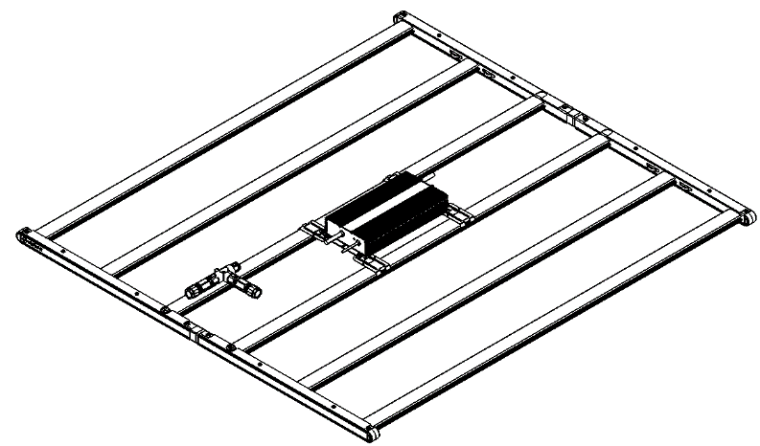

**Figure A.1: VPS HIGH OUTPUT**

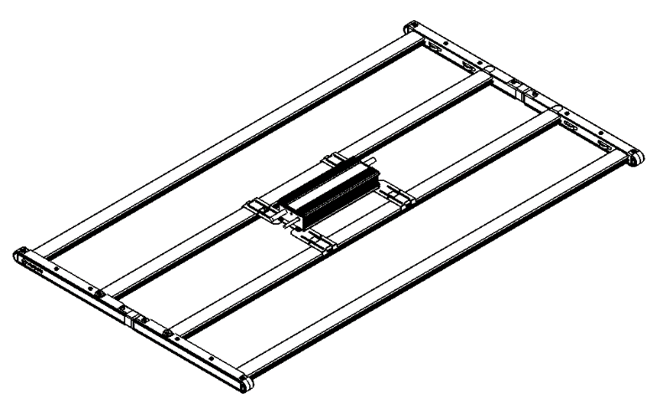

**Figure A.2: VPS MED OUTPUT**

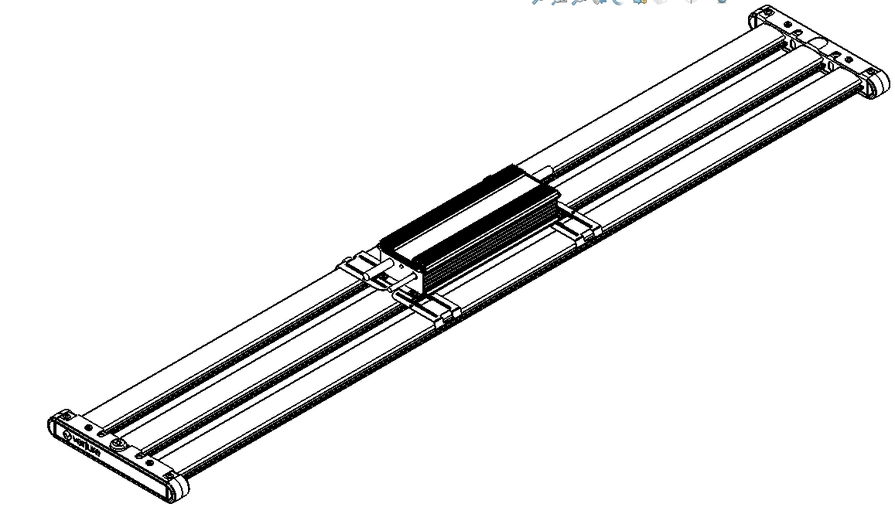

**Figure A.3: VPS NARROW GREENHOUSE**

**SECTION B: ASSEMBLY INSTRUCTIONS**

**Take caution when handling the led modules. Ensure the LED arrays are not damaged.**

1. Remove the new VPS luminaire from packaging and inspect for any damages. Handle new LED fixture with care. If damaged do not use; call your local rep for replacement.
2. Place the LED modules on a flat and stable surface.
3. If assembling a VPS high or medium output fixture, connect the two LED modules using the frame connector mechanisms. Ensure the spring clip is fully engaged and secured to the LED modules.
4. When mounting the driver to the fixture, make sure the LEDs are facing down against the flat surface. Snap the mounting brackets (qty:4) in desired position based on the driver’s mounting holes. Install the #8 screws to secure the driver to the mounting bracket as shown below.

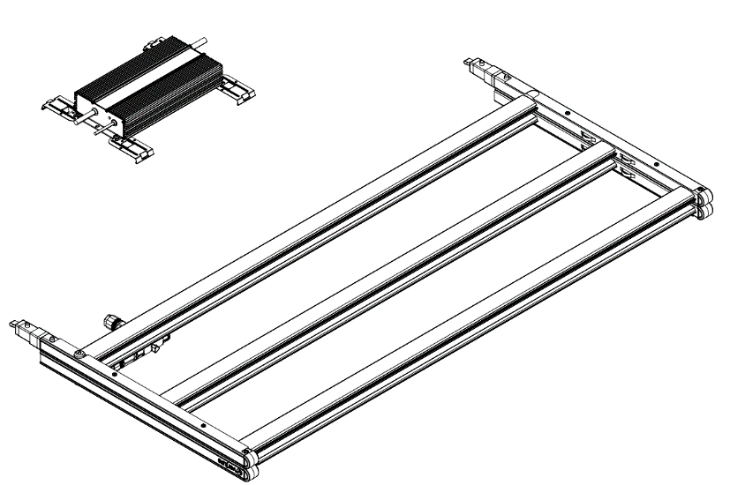

**Figure B.2: HIGH/MED OUTPUT (REMOVED FROM PACKAGING)**

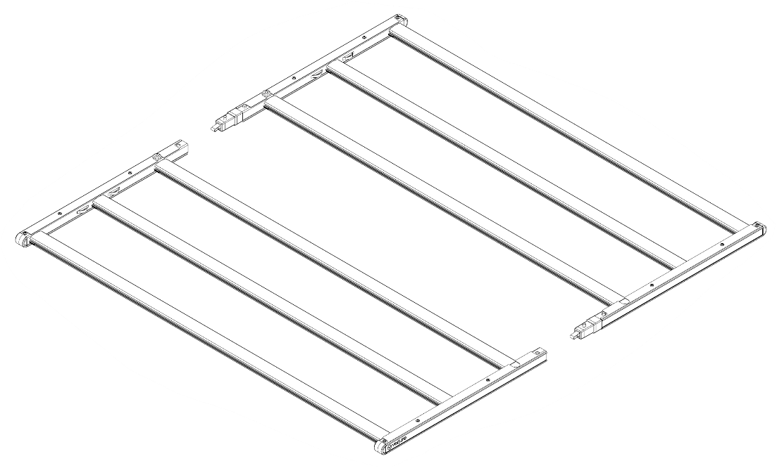

FRAME CONNECTOR

**Figure B.3: HIGH/MED OUTPUT (QUICK-CONNECT)**

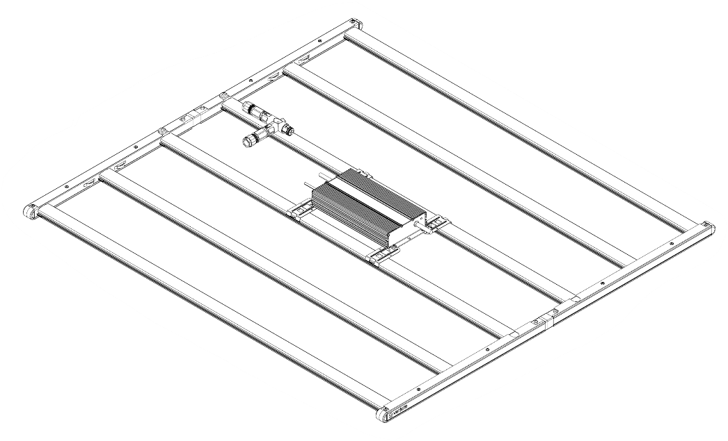

**Figure B.4: Driver mounting**

**SECTION C: PRE-INSTALLATION FOR ALL MOUNTING**

1. Ensure power is OFF.
2. If new construction, add mounting hardware to install the new VPS luminaire. Ensure mounting structure is properly sized to support the weight of the fixture.
3. Disconnect all power to the existing luminaire and remove the existing luminaire from the ceiling. Inspect the existing mounting location for damage before installing the new VPS luminaire in this location. Ensure mounting structure is properly sized to support the weight of the fixture.
4. Customer provided cable glands may be installed between the luminaire and conduit to reduce condensation inside of conduit from entering luminaire. Use cable glands suitable for your end use application.
5. After installation ensure no wires are pinched or caught outside the electrical door.

**SECTION D: INSTALLATION – SUSPENDED FIXTURE**

1. If using the VIBAC120 or VIBAC240, hook the latch around the suspended mounting feature on end channel.
2. Secure the other end of the aircraft cable to a structure using hardware rated for the load. Contact factory or agency for areas that have vibration, overhead cranes and/or high velocity.
3. The VPS Greenhouse series latches through the frame.
4. If attaching the VPS Greenhouse using the MH2HK. Wrap the cable around the pipe/strut and connect to the VPS fixture. Adjust to desired height.

 Make sure the latches are fully engaged around the mounting feature.

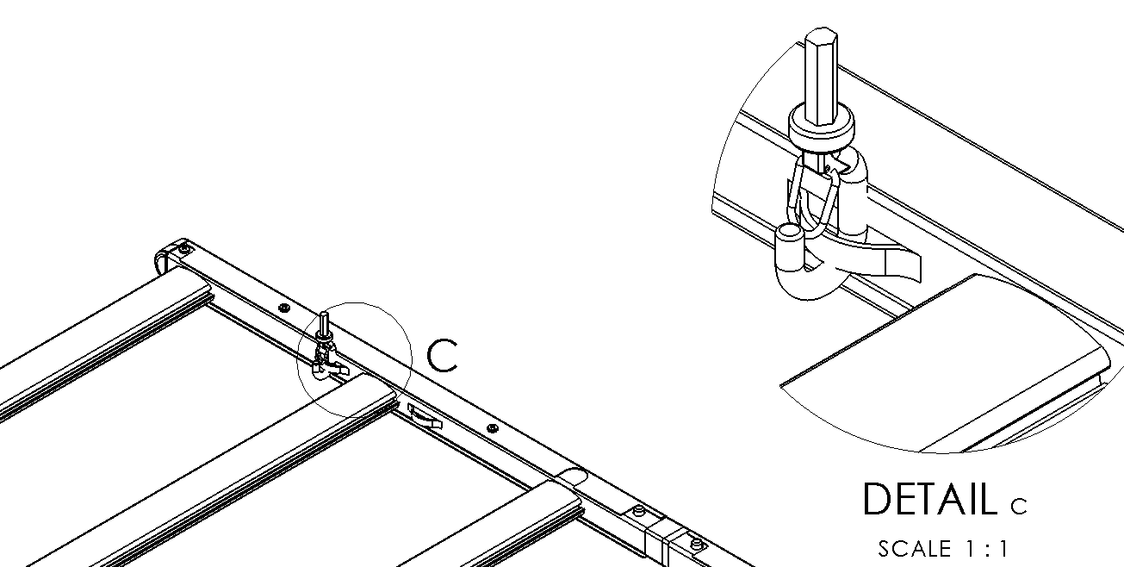

AIRCRAFT CABLE ATTACHED LANCES

(AS SHOWN)

**Figure D.1: HIGH/MED OUTPUT- Suspended Mounting**

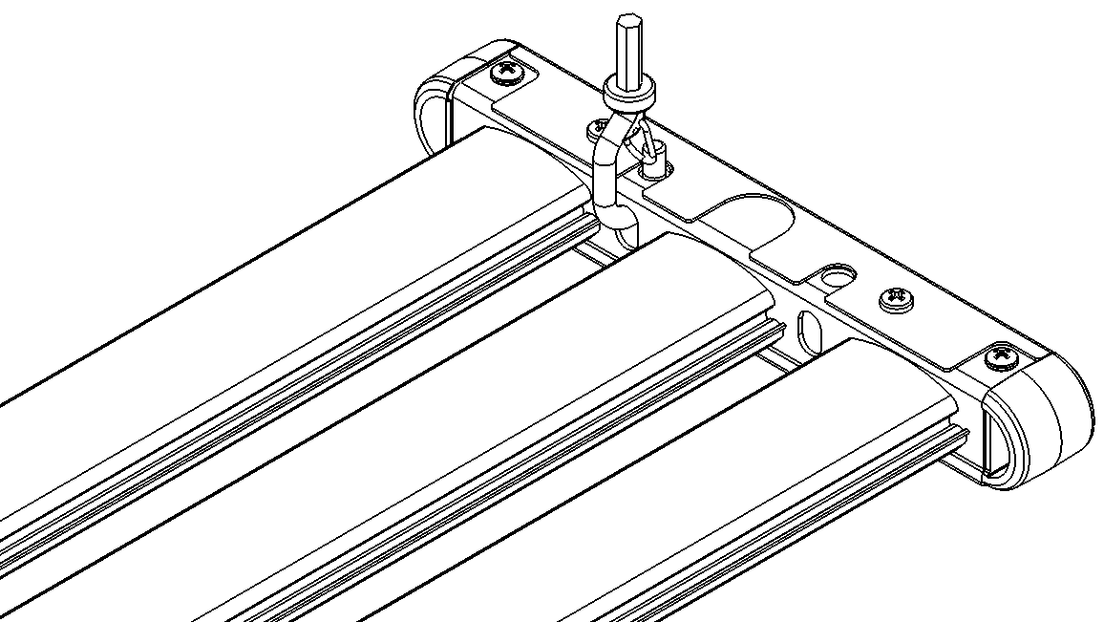

AIRCRAFT CABLE ATTACHED HERE

(AS SHOWN)

**Figure D.3: NARROW GREENHOUSE- Suspended Mounting**

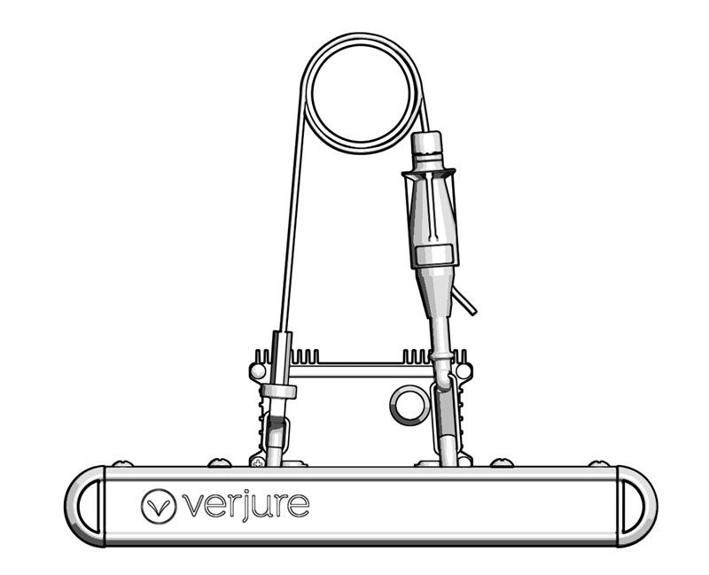

To raise adjustable suspension, to release cable press/hold in and pull cable out. Trim if necessary.

To lower adjustable suspension, release cable by press/holding in top cap while pulling cable out.

Wrap cable around the

Pipe/Strut

**Figure D.4: NARROW GREENHOUSE- Pipe/Strut Mounting**

**Section E: Installation – nLight Air rIO or AO Option**

1. rIO and AO will be pre-wired to the driver and mounted inside of the sensor box.
2. Snap mounting bracket to extrusion then mount control box to the bracket using the supplied #8 screws (qty:2).
3. Install fixture based on specified mounting instructions.

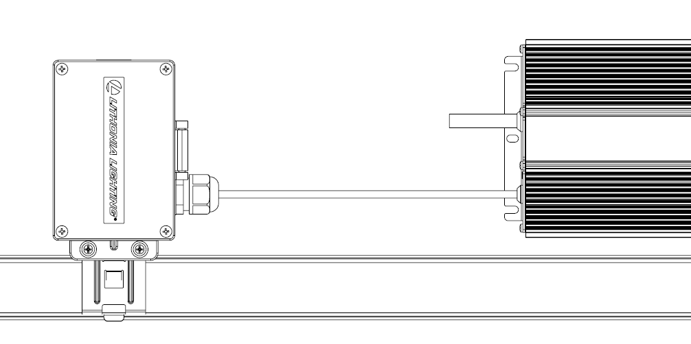

DRIVER OUTPUT

TO LED (SECTION I)

**Figure E.1: Control Box Installation**

**Section F: Wiring – CUSTOMER CONNECTION**

1. Install fixture based on specified mounting instructions.
2. Connect quick connections on driver input and output side
3. Input wires are to be quick connected to the driver’s input leads. Connect switched power to white, black, and green wires. Supply wire must meet applicable electrical codes and be rated for a minimum of 90⁰C. Purple and pink (or gray) leads are 0-10V (low voltage) dimming leads.

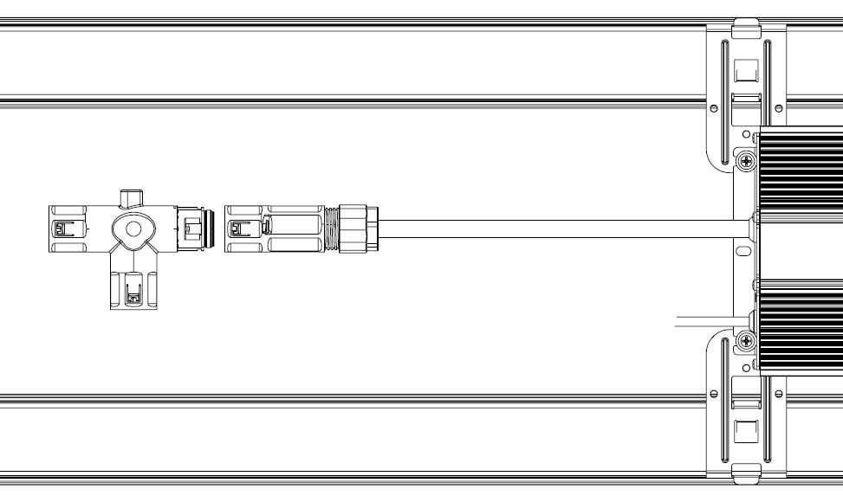

DRIVER OUTPUT

TO RIO or AO OPTION (SECTION H)

PUSH TO CLICK ENGAGEMENT

**Figure F.2: Quick connections (output side as example)**

**SECTION G: SERVICING**

1. Clean fixture as needed using a damp rag only. Do not use any cleaning chemicals on the lenses or LED boards. Double check all mounting hardware.
2. After installation, wear protective gloves if the lens needs to be removed.
3. If replacing driver, ensure to disconnect all power to the LED fixture being service. Read LED safety instructions on page 1.
4. If replacing LED module, ensure to disconnect all power to the LED fixture being service. Read LED safety instructions on page 1. Follow the exploded view instructions below for each model type.
   1. Remove wire cover screws (item 12, qty 4), place covers to side (item 8), protecting them for reuse.
   2. Disconnect wiring to the LED module.
   3. Remove mounting screws (item 15, qty 4) and keep screws for reuse.
   4. Remove LED module; might need to loosen one side of other LED modules to provide clearance.
   5. Replace module in reverse order as above.

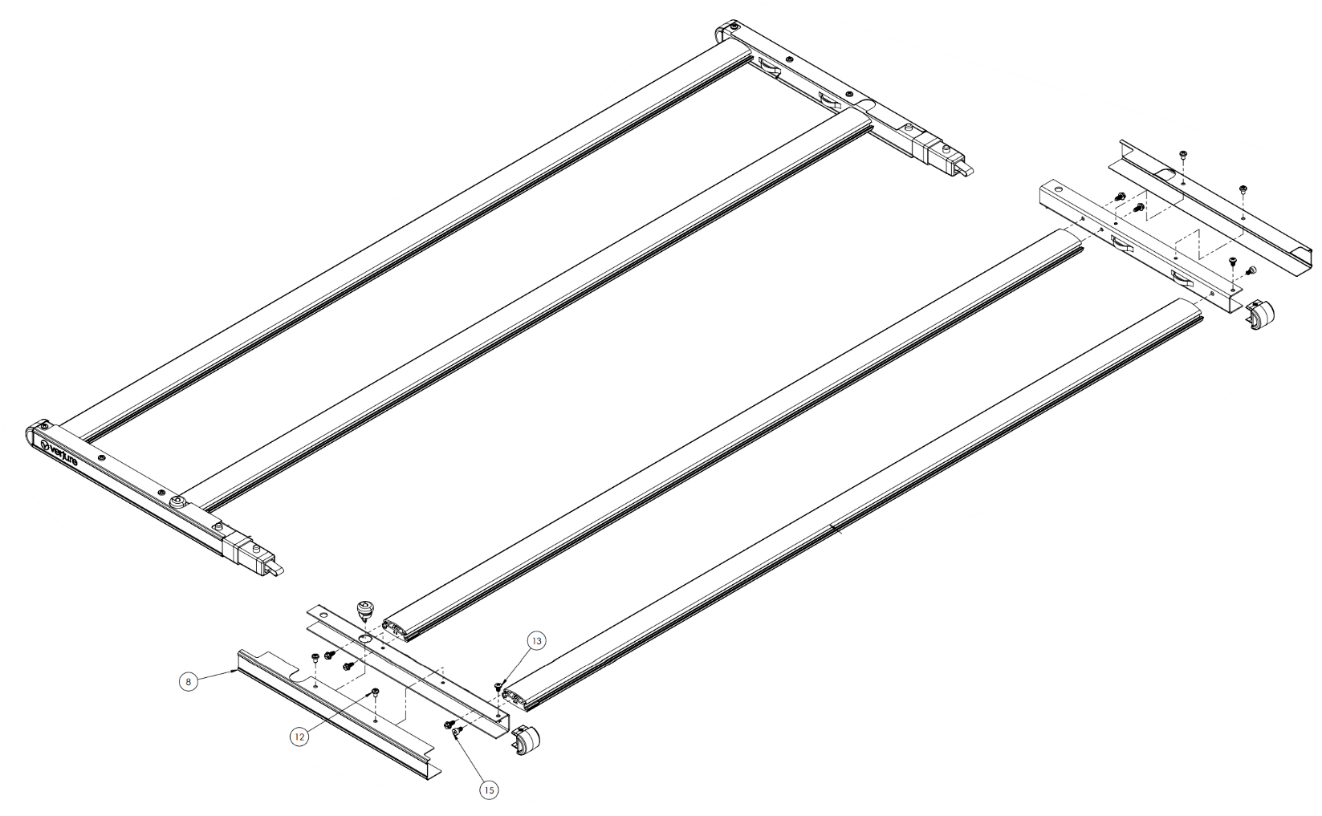

LED MODULE

**Figure G.4: LED module exploded view detail**